A PROJECT REPORT ON

A SLEEP TRACKING APP FOR A BETTER NIGHT’S REST

BACHELOR OF COMPUTER APPLICATION
DEVANGA ARTS COLLEGE,
(Affiliated to Madurai Kamaraj University)
Aruppukottai 626101.

Submitted
By

C. SELVAGURU (REG NO. C0S41823)
A. SATHISH KUMAR (REG NO. C0S41822)
B. VEILRAJA (REG NO. C0S41825)

UNDER THE GUIDENCE OF
Mr. V. GNANASEKARAN M.Sc..,

DEVANGA ARTS COLLEGE
(AFFILIATED TO MADURAI KAMARAJ UNIVERSITY)
ARUPPUKOTTAI 626 101.

INTRODUCTION:
we had a variety of topics to choose from, Exercise & Fitness, Sleep quality & cycle analysis, Eating & healthy diet, stress reduction, relaxation & meditation from the Wellness segment and Bill-tracking, Taxes or Managing income, expenses & savings from Finance.
Our choice landed on creating a sleeping application that focuses on improving the sleep quality of people and works without a wearable device.

Features & Scope
Which features/functionalities to include was open for proposals by all the students, As this is an MVP (Minimum Viable Product), the app should not try to solve all of the user’s problems at the same time. Each design should focus on:

• ONE aspect of either the wellness or the finance industry that the designer considers important (backed up by user research)

• Data visualization

For the purpose of this project, we wanted the prototype to focus on the main user flow that will be the defining factor of the user experience. To reach our goal of a user-focused design we used a lot of different techniques & tools which I will explain in detail.

  - OVERVIEW
Smartphone sleep apps claim to measure your body’s movements using the phone’s accelerometer to track restlessness during the night. It’s easy enough – download one of these apps, then put your phone facedown next to you while sleeping. Many of these apps will provide you with a report of how many times you woke up and what times during the night you were active. However, as Montgomery-Downs notes, it’s important to remember that the devices currently on the market can’t truly identify when you’re sleeping or awake. It’s important to talk to your doctor if you feel you have a sleep disorder, such as insomnia.

Alternatively, sleep tracking devices can be worn on the wrist or clipped to your PJs during the night, using built-in accelerometers and software to track your sleep patterns over time. These devices may also be more accurate than apps, since they reduce the chance that movement by a pet or bedmate is registered.

  - PURPOSE
With the availability of numerous sleep tracking devices and apps, it has become easier to understand your sleep patterns and even identify the reasons for disturbed sleep. There are tracking devices that you can wear on your wrists, clip them on your pillow, or rest on the bedside table.

Why Should You Use a Sleep Tracker?

These devices and apps use motion sensing to decide whether you are awake or asleep. When there is movement, they register you as awake, and when there is no movement, they presume you are asleep. These gadgets and apps can help you track the total number of hours you sleep, the sleep and wake cycle, and the number of times you woke up during the night.

The common data points tracked include:

Sleep duration: By tracking the time when there is no movement.

Sleep quality: By tracking the interruptions to your night sleep.

Sleep phases: By tracking the phases of your sleep and setting off an alarm when your sleep is light.

Environmental factors: By tracking parameters such as the temperature or the amount of light of the bedroom.

Lifestyle factors: By tracking the information about factors that can potentially disrupt your sleep.

All of these data points can provide your healthcare practitioner with useful insights to judge if there are serious disorders or underlying health challenges in your current sleep patterns.

However, there is a vast difference in the type and depth of data that the tracking app or devices can gather. Also, there is a concern about the accuracy of data captured. A lot of the devices, especially those at the less expensive end of the spectrum, provide guesstimates at best because they cannot differentiate between sleep and just lying in the bed.

Additionally, not all trackers can accurately measure the total sleep/wake time and suggest that there is an underlying problem with the sleep pattern. This is especially true for naps, because naps taken during the day can influence the night sleep. Also, commercial trackers are not truly effective when it comes to tracking the time a person gets a light sleep and during the slow wave and REM (rapid eye movement) stages of sleep.

But that being said, the need for accuracy in sleep trackers is largely dependent on why you are using it. If you are in general good health and wish to use a sleep tracker to simply understand your overall sleep pattern, the available range of trackers with general, big-picture data is helpful. However, if you experience symptoms like headaches, fatigue, daytime sleepiness etc. consistently, and suspect it might be related to your sleep or lack thereof, then you need a more accurate kind of sleep tracker.

2. Problem Definition & Design Thinking
2.1 Empathy Map

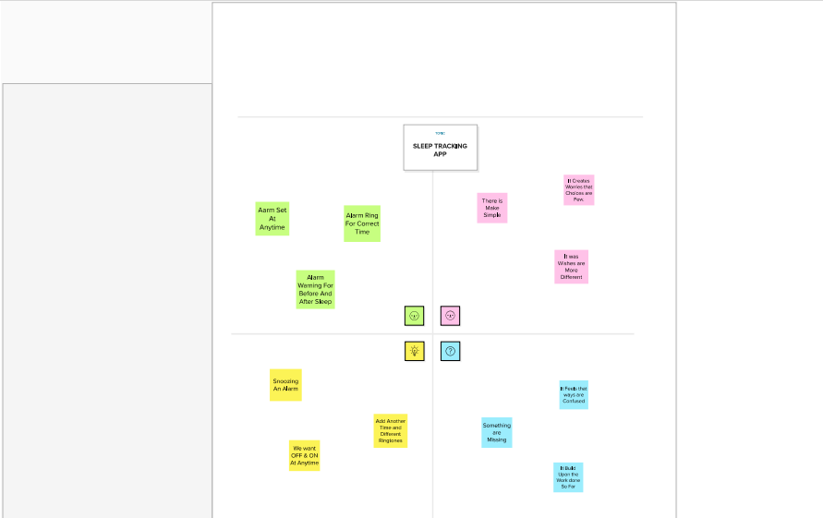

2.2 Ideation & Brainstorming Map

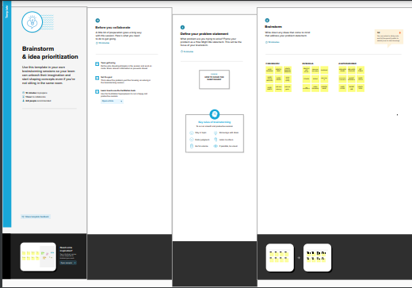

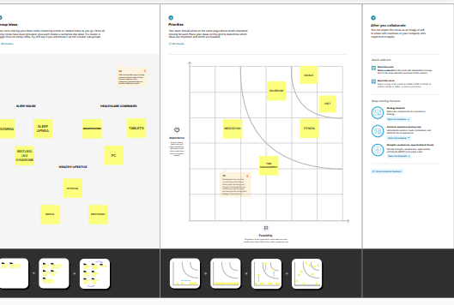

3. RESULT

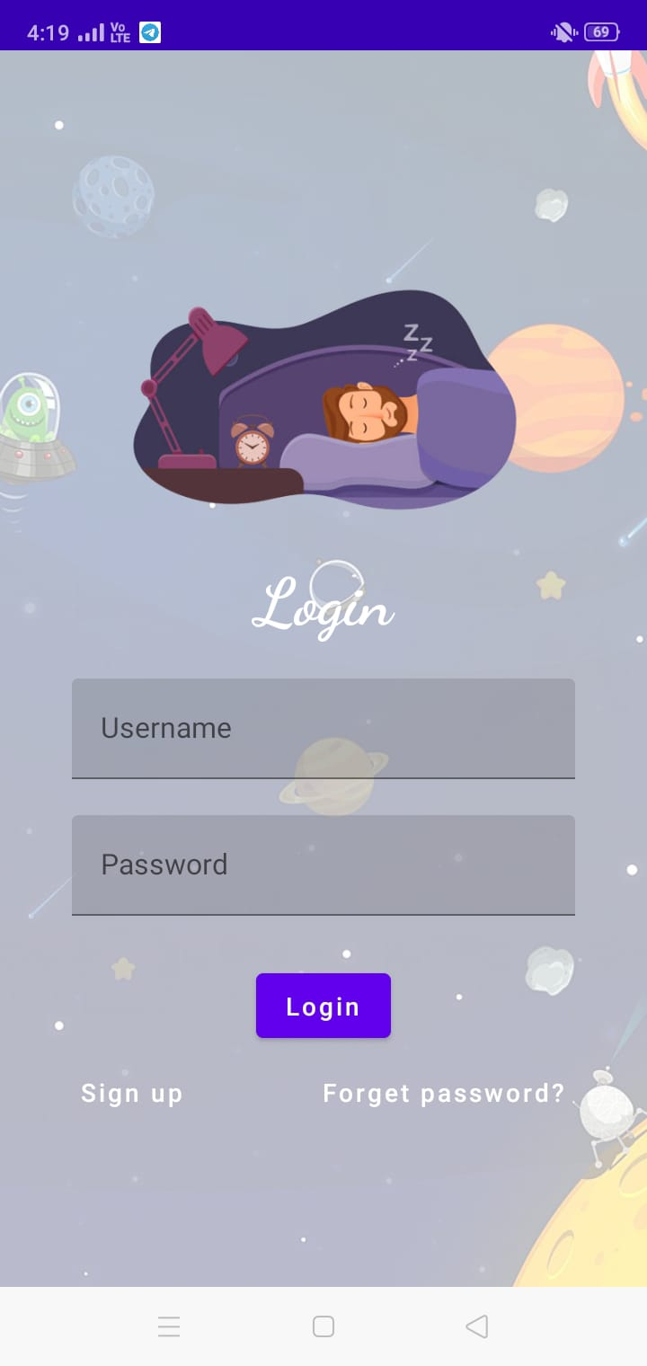

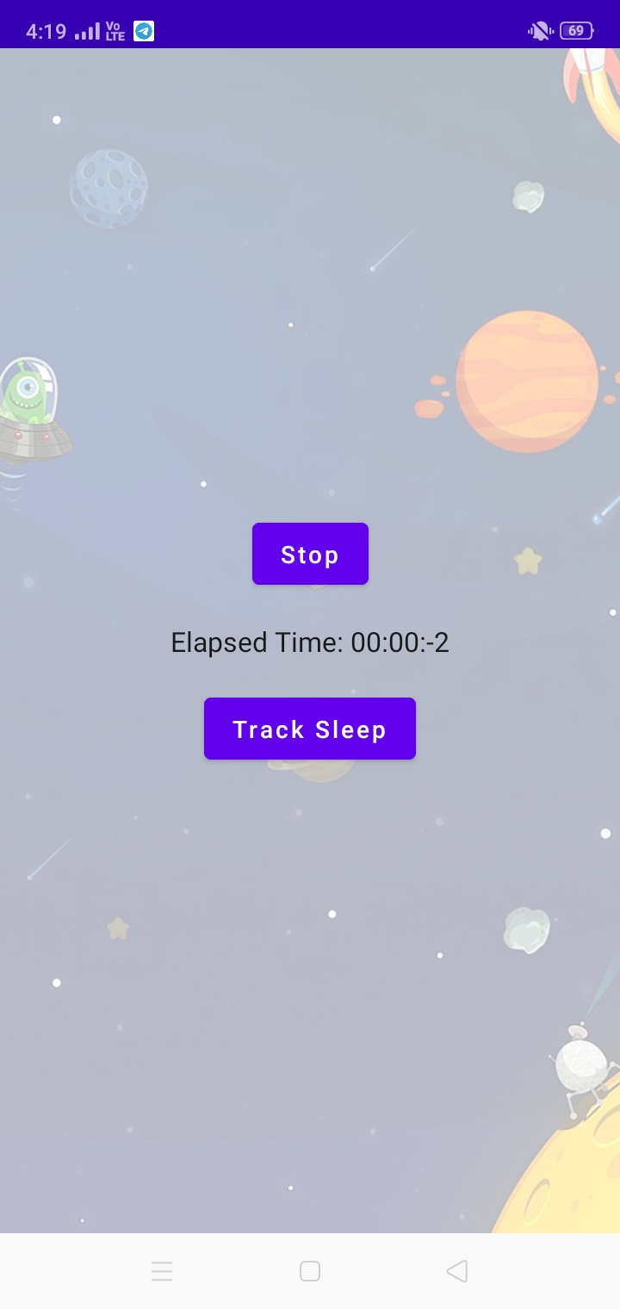
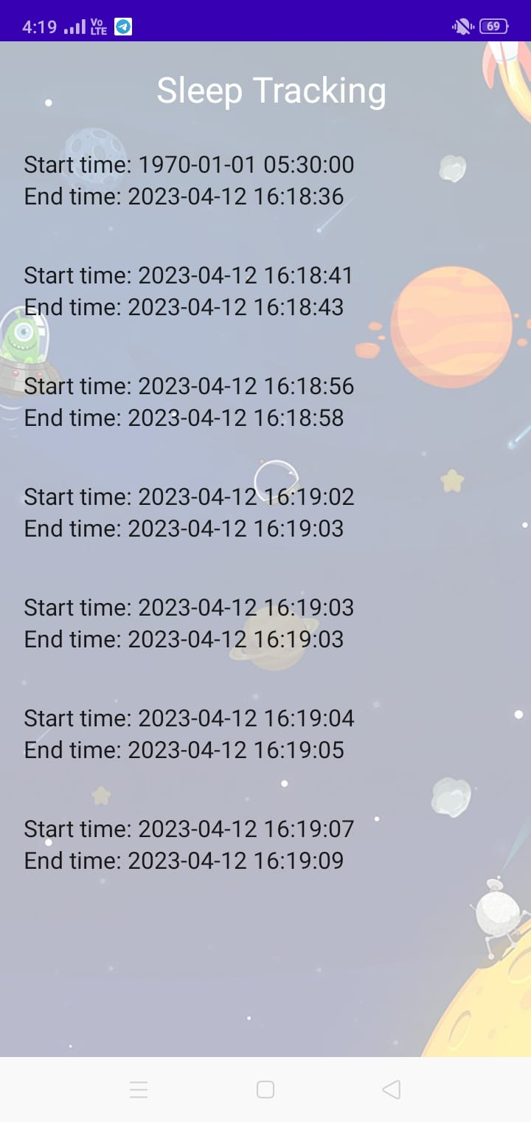
4. ADVANTAGES & DISADVANTAGES

Advantages:-

With the availability of numerous sleep tracking devices and apps, it has become easier to understand your sleep patterns and even identify the reasons for disturbed sleep. There are tracking devices that you can wear on your wrists, clip them on your pillow, or rest on the bedside table.

Why Should You Use a Sleep Tracker?

These devices and apps use motion sensing to decide whether you are awake or asleep. When there is movement, they register you as awake, and when there is no movement, they presume you are asleep. These gadgets and apps can help you track the total number of hours you sleep, the sleep and wake cycle, and the number of times you woke up during the night.

The common data points tracked include:

Sleep duration: By tracking the time when there is no movement.

Sleep quality: By tracking the interruptions to your night sleep.

Sleep phases: By tracking the phases of your sleep and setting off an alarm when your sleep is light.

Environmental factors: By tracking parameters such as the temperature or the amount of light of the bedroom.

Lifestyle factors: By tracking the information about factors that can potentially disrupt your sleep.

All of these data points can provide your healthcare practitioner with useful insights to judge if there are serious disorders or underlying health challenges in your current sleep patterns.

However, there is a vast difference in the type and depth of data that the tracking app or devices can gather. Also, there is a concern about the accuracy of data captured. A lot of the devices, especially those at the less expensive end of the spectrum, provide guesstimates at best because they cannot differentiate between sleep and just lying in the bed.

Additionally, not all trackers can accurately measure the total sleep/wake time and suggest that there is an underlying problem with the sleep pattern. This is especially true for naps, because naps taken during the day can influence the night sleep. Also, commercial trackers are not truly effective when it comes to tracking the time a person gets a light sleep and during the slow wave and REM (rapid eye movement) stages of sleep.

But that being said, the need for accuracy in sleep trackers is largely dependent on why you are using it. If you are in general good health and wish to use a sleep tracker to simply understand your overall sleep pattern, the available range of trackers with general, big-picture data is helpful. However, if you experience symptoms like headaches, fatigue, daytime sleepiness etc. consistently, and suspect it might be related to your sleep or lack thereof, then you need a more accurate kind of sleep tracker.

Disadvantages:-

There are a few potential disadvantages of sleep tracking apps:

1. Inaccuracy: Sleep tracking apps rely on sensors such as accelerometers or heart rate monitors, which may not provide fully accurate data. For example, a sleep tracking app may mistake periods of restlessness for deep sleep, leading to incorrect data.

2. Disruption of sleep: Some people may find that wearing a device or having their phone nearby while they sleep disrupts their sleep patterns, leading to poorer quality sleep overall.

3. Over-reliance on technology: Relying on a sleep tracking app to monitor your sleep can create a dependence on technology and may prevent you from being able to accurately assess your own sleep patterns without the assistance of an app.

4. Obsession: Some people may become obsessed with tracking their sleep and may become overly focused on achieving perfect metrics, leading to increased stress and anxiety.

5. Privacy concerns: Sleep tracking apps often collect sensitive data about a user's sleep patterns, which may be shared with third-party companies or used for targeted advertising, raising concerns about data privacy and security.

5. APPLICATIONS
Here are some solutions to address the potential downsides of sleep tracking apps:
- Improve accuracy: Sleep tracking apps can improve their accuracy by using more advanced sensors and machine learning algorithms to better interpret sleep data. Additionally, users can calibrate their devices and wearables to ensure they are properly positioned and functioning correctly.
- Minimize disruption of sleep: Users can minimize disruption of sleep by using sleep tracking apps that do not require wearing a device or keeping a phone nearby. Additionally, using "night mode" or "do not disturb" settings on phones can help reduce interruptions during sleep.
- Avoid over-reliance on technology: Users can avoid becoming overly reliant on technology by using sleep tracking apps as a tool to supplement their own awareness of their sleep patterns, rather than as the sole source of information.
- Manage obsession: Users can manage their obsession with tracking their sleep by setting realistic goals and focusing on overall trends rather than fixating on individual metrics.
- Ensure privacy: Users can ensure their privacy by carefully reviewing privacy policies and terms of service for sleep tracking apps to understand how their data is collected, used, and shared. Additionally, users can choose apps that have strong privacy and security features and avoid sharing sensitive data with third-party companies.
By addressing these areas, sleep tracking apps can become even more valuable tools for monitoring and improving sleep quality while minimizing potential downsides.

6. CONCLUSION
In conclusion, sleep tracking apps can be a useful tool for monitoring and improving sleep quality. They can provide valuable insights into an individual's sleep patterns and help identify areas for improvement. However, there are also potential downsides to using these apps, such as inaccuracy, disruption of sleep, and privacy concerns.

Looking to the future, sleep tracking apps hold great potential for improving sleep health through increased accuracy, personalization, and integration with other health data and technologies. As technology continues to advance, we can expect sleep tracking apps to become even more sophisticated and effective at helping individuals optimize their sleep. However, it is important to use these apps in moderation and to be mindful of the potential downsides, so that we can reap the benefits of sleep tracking without compromising our overall health and well-being.

7. FUTURE SCOPE

The future of sleep tracking apps is exciting and holds great potential. Here are some possible future developments:

1. Improved accuracy: As technology continues to improve, sleep tracking apps may become more accurate, using more advanced sensors and machine learning algorithms to better interpret sleep data.

2. Personalized insights: Sleep tracking apps may use data and AI to provide personalized recommendations for improving sleep based on each individual's unique sleep patterns and habits.

3. Integration with other health data: As more health data is collected through wearable devices and other health monitoring tools, sleep tracking apps may be integrated with this data to provide a more comprehensive view of an individual's overall health.

4. Smart home integration: Sleep tracking apps may be integrated with smart home devices, such as lighting systems or temperature controls, to create an optimal sleep environment tailored to each individual's preferences.

5. Clinical applications: Sleep tracking apps may be used in clinical settings to diagnose and treat sleep disorders, or to monitor the sleep patterns of patients with chronic health conditions.

Overall, the future of sleep tracking apps is likely to be characterized by increased accuracy, personalization, and integration with other health data and technologies.

8. APPENDIX
Sample Source code
# Workflow to ensure whenever a Github PR is submitted,
# a JIRA ticket gets created automatically.
name: Manual Workflow
# Controls when the action will run.
on:
# Triggers the workflow on pull request events but only for the master branch
pull_request_target:
types: [opened, reopened]
# Allows you to run this workflow manually from the Actions tab
workflow_dispatch:
jobs:
test-transition-issue:
name: Convert Github Issue to Jira Issue
runs-on: ubuntu-latest
steps:
- name: Checkout
uses: actions/checkout@master
- name: Login
uses: atlassian/gajira-login@master
env:
JIRA_BASE_URL: ${{ secrets.JIRA_BASE_URL }}
JIRA_USER_EMAIL: ${{ secrets.JIRA_USER_EMAIL }}
JIRA_API_TOKEN: ${{ secrets.JIRA_API_TOKEN }}
- name: Create NEW JIRA ticket
id: create
uses: atlassian/gajira-create@master
with:
project: CONUPDATE
issuetype: Task
summary: |
Github PR nd940 - Android Kotlin Developer | Repo: ${{ github.repository }} | PR# ${{github.event.number}}
description: |
Repo link: https://github.com/${{ github.repository }}
PR no. ${{ github.event.pull_request.number }}
PR title: ${{ github.event.pull_request.title }}
PR description: ${{ github.event.pull_request.description }}
In addition, please resolve other issues, if any.
fields: '{"components": [{"name":"nd940 - Android Kotlin Developer"}], "customfield_16449":"https://classroom.udacity.com/", "customfield_16450":"Resolve the PR", "labels": ["github"], "priority":{"id": "4"}}'
- name: Log created issue
run: echo "Issue ${{ steps.create.outputs.issue }} was created"

